Hydra Commands
The options we pass into Hydra depend on which service (protocol) we’re attacking. For example, if we wanted to brute force FTP with the username being user and a password list being passlist.txt, we’d use the following command:
hydra -l user -P passlist.txt ftp://10.10.208.216
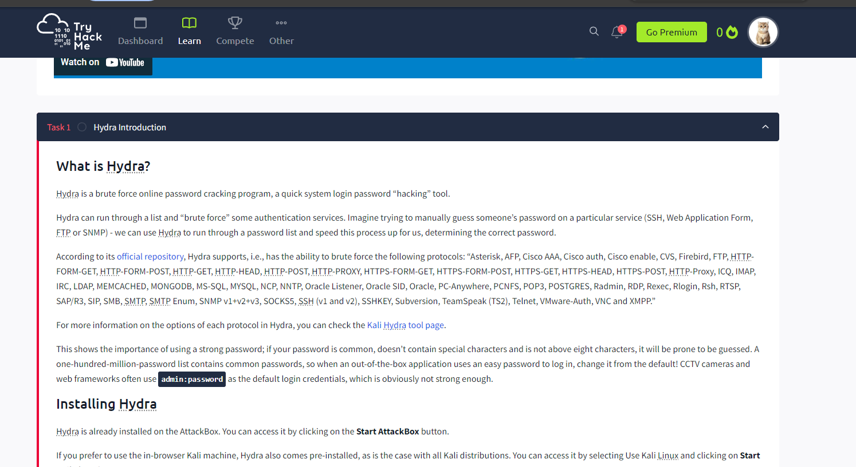

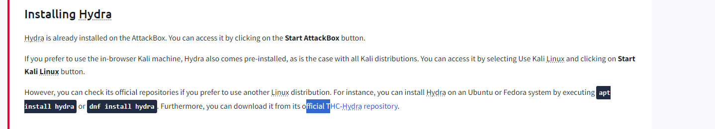

SSH
hydra -l <username> -P <full path to pass> 10.10.208.216 -t 4 ssh
Option | Description
-l | specifies the (SSH) username for login
-P | indicates a list of passwords
-t | sets the number of threads to spawn
For example,
hydra -l root -P passwords.txt 10.10.208.216 -t 4 ssh will run with the following arguments:
- Hydra will use root as the username for ssh
- It will try the passwords in the passwords.txt file
- There will be four threads running in parallel as indicated by -t 4

Post Web Form
We can use Hydra to brute force web forms too. You must know which type of request it is making; GET or POST methods are commonly used. You can use your browser’s network tab (in developer tools) to see the request types or view the source code.
sudo hydra <username> <wordlist> 10.10.208.216 http-post-form "<path>:<login_credentials>:<invalid_response>"
Option | Description
-l | the username for (web form) login
-P | the password list to use
http-post-form | the type of the form is POST
<path> | the login page URL, for example, login.php
<login_credentials> | the username and password used to log in, for example, username=^USER^&password=^PASS^
<invalid_response> | part of the response when the login fails
-V | verbose output for every attempt
Below is a more concrete example Hydra command to brute force a POST login form:
hydra -l <username> -P <wordlist> 10.10.208.216 http-post-form "/:username=^USER^&password=^PASS^:F=incorrect" -V
- The login page is only /, i.e., the main IP address.
- The username is the form field where the username is entered
- The specified username(s) will replace ^USER^
- The password is the form field where the password is entered
- The provided passwords will be replacing ^PASS^
- Finally, F=incorrect is a string that appears in the server reply when the login fails

Room Practical
IP ADDRESS : 10.10.208.216

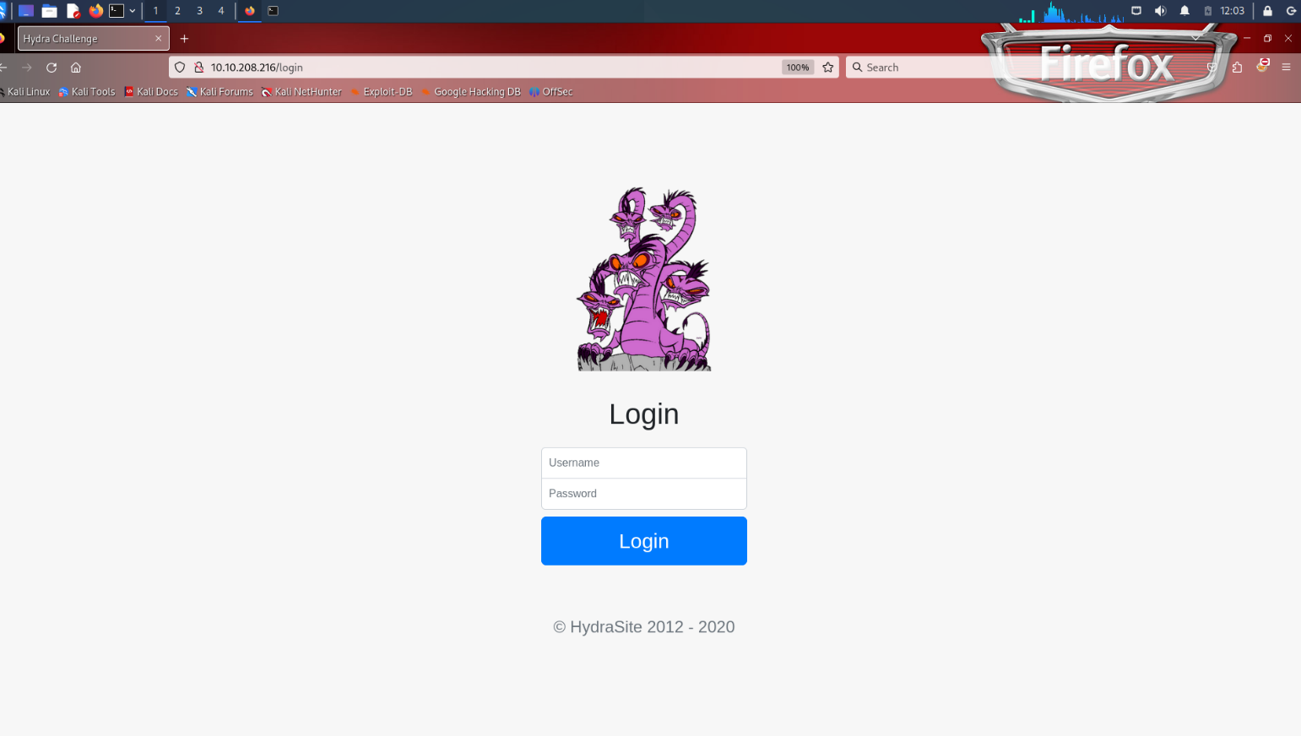

Use Hydra to bruteforce molly's web password.
What is flag 1?
